

Dear Parents and Carers, December 2025

We hope you and your children are enjoying their time at our after school sports clubs. We are writing to let you know about an important change to our pricing structure.
As our company has continued to grow, we are now required to pay VAT on our services. Unfortunately, this means we must adjust our session fees to reflect the additional costs. The VAT adds 80 pence per session, so the price of each after school club session will change from £4 to £4.80.
We understand that any increase, even a small one, can have an impact on families. We have therefore introduced a monthly instalment option to help make payments more manageable. This allows you to spread the cost over the term.
We remain committed to providing high quality, engaging and affordable sports coaching for all children. Thank you for your continued support and understanding as we make the adjustments required to keep delivering the best possible service.
If you have any questions, please feel free to contact us.

Kind Regards,

Aaron Merredew

Dear Parents and Carers
Please see below details of the clubs that I will be running for the Spring term. New members are always welcome.
Please copy and paste this link to your browser to book on via our new app. Once on the app, head to the schools tab, find your school and club and complete the registration form. We also now offer a 3 month subscription to spread the cost.
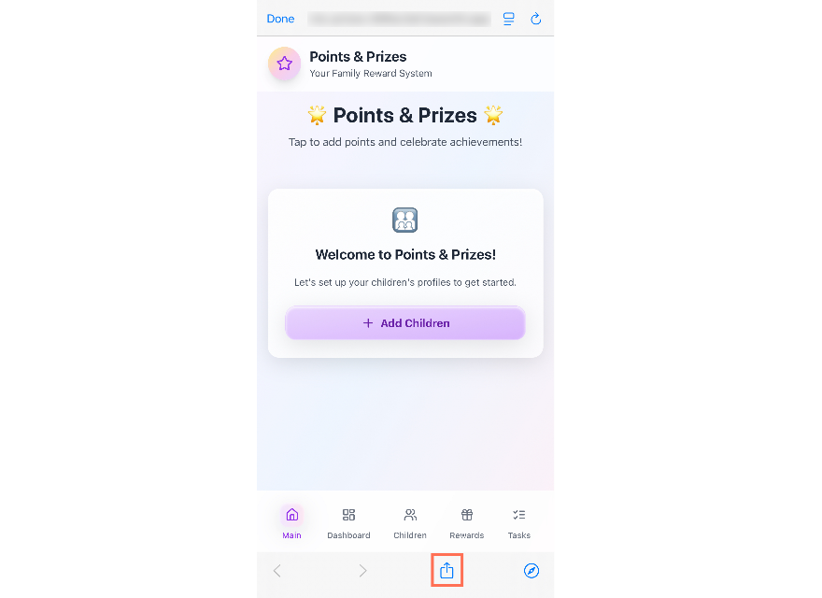
https://ajm-club-finder-8715b9ea.base44.app
To add your app to the home screen:
- Open the app link in your mobile browser.
- Tap the Share icon (the square with the arrow pointing up; on Android, this may appear as three dots).
- Tap Add to Home Screen.
- Edit the shortcut name if you want, then tap Add.
Clubs will start at 3.30pm and finish at 4.30pm. The aim of the clubs is to have fun whilst improving your child’s sporting skills. If you have any questions at all, please do let me know.
Regards
Aaron Merredew - BSc Sports Coaching
Mobile: 07875 108666 Email: ajmsportscoaching@hotmail.co.uk

Club | Eligible Year Groups | Start Date | End Date | Duration of club | Total cost | Please tick
Multi Sports | Y3,Y4,Y5 and Y6 | Mon 12th Jan | Mon 23rd Mar | 10 Weeks | £48
Gymnastics | Y1,Y2,Y3 | Tues 8th Jan | Tues 26th Mar | 11 Weeks | £52.80
Football Club | Y3,Y4,Y5 and Y6 | Weds 7th Jan | Weds 25th Mar | 11 weeks | £52.80
Multi Sports | Y1,Y2,Y3 | Thurs 8th Jan | Thurs 26th Mar | 11 Weeks | £52.80
Girls Football | Y3, Y4,Y5 and Y6 | Fri 9th Jan | Fri 27th Mar | 11 weeks | £52.80
Football | Y1,Y2 | Fri 9th Jan | Fri 27th Mar | 11 Weeks | £52.80
 |  |  |  | Total due

Virgin, sort code 82-19-74, account number 30012000, account name AJM Sports Limited PLEASE STATE CHILD’S NAME AS REFERENCE
Please ensure that your child has appropriate sports kit and plenty of water.

