

Dear Parents and Carers, July 2026

Please see below details of the clubs that we will be running for the Autunm term. New members are always welcome.
At AJM Sports Coaching, our aim is to create a positive environment where children can develop new skills, build confidence, make friends, and enjoy being active. Our qualified and experienced coaches deliver sessions that are inclusive, enjoyable, and suitable for children of all abilities.
Please click on the link below to complete the online booking form.
After-school clubs cost £4.80 per session and run from 3:30pm to 4:30pm.
We look forward to welcoming your child to our Autumn Term sports clubs!
The aim of the clubs is to have fun whilst improving your child’s sporting skills. If you have any questions at all, please do let me know.
Kind Regards,
Aaron Merredew - BSc Sports Coaching
Mobile: 07875 108666 Email: ajmsportscoaching@hotmail.co.uk

Club | Eligible Year Groups | Start Date | End Date | Duration of club | Total cost | Please tick
Multi Sports | Y3,Y4,Y5,Y6 | Mon 7th Sept | Mon 14th Dec | 14 Weeks | £67.20
Football | Y1,Y2 | Mon 7th Sept | Mon 14th Sept | 14 Weeks | £67.20
Gymnastics | Y1,Y2,Y3 | Tues 8th Sept | Tues 15th Dec | 14 Weeks | £67.20
Football | Y3,Y4,Y5,Y6 | Weds 9th Sept | Weds 16th Dec | 14 Weeks | £67.20
Girls Football | Y3,Y4,Y5,Y6 | Fri 11th Sept | Fri 18th Dec | 14 Weeks | £67.20
 |  |  |  | Total due

Virgin, sort code 82-19-74, account number 30012000, account name AJM Sports Limited PLEASE STATE CHILD’S NAME AS REFERENCE
Please ensure that your child has appropriate sports kit and plenty of water.

Please copy and paste this link to your browser to book on via our new app. Once on the app, head to the schools tab, find your school and club and complete the registration form. We also now offer a 3 month subscription to spread the cost.
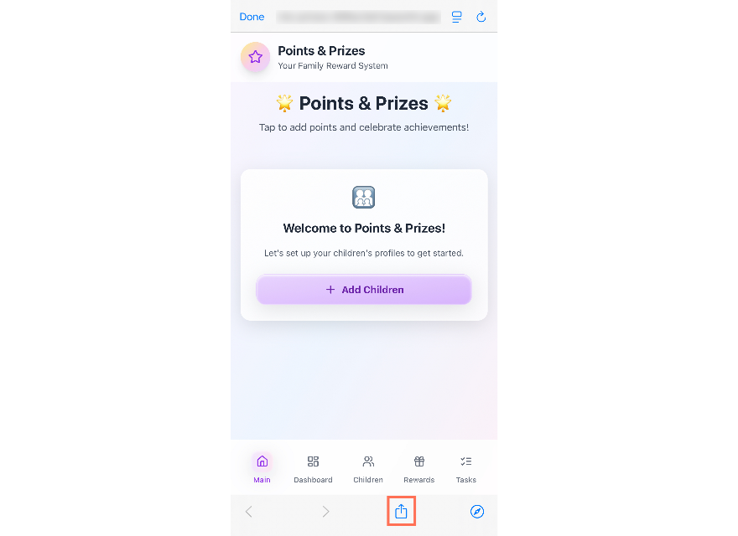
https://ajm-club-finder-8715b9ea.base44.app
To add your app to the home screen:
- Open the app link in your mobile browser.
- Tap the Share icon (the square with the arrow pointing up; on Android, this may appear as three dots).
- Tap Add to Home Screen.
- Edit the shortcut name if you want, then tap Add.

