Swanage Primary school: Uniform
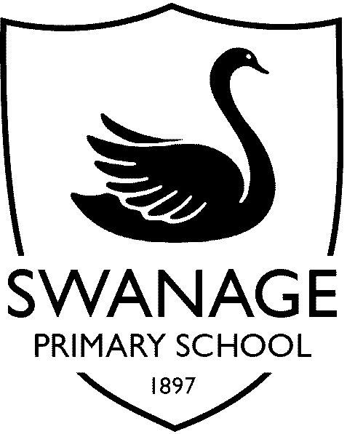
Option 1
Option 2
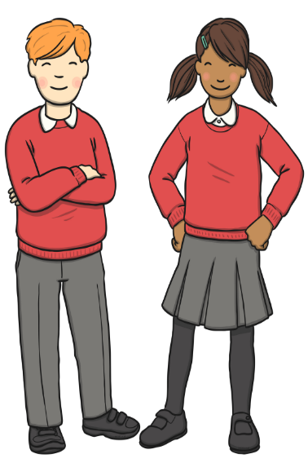
Hair/Hair bands
We ask that long hair is tied back and that hair bands are kept ‘subtle’ and in school colours.
Nb Winter footwear
Please note that in cold weather, children may wear ‘sensible, smart’ black boots instead of shoes.
NO fashion boots/shoes with a large heal should be worn.
School Shoes
Sports trainers are not permitted at SPS but Clarks and other shoe shops/supermarkets are now selling ‘trainer type’ school shoes and these are great as long as they are:
*Flat (non-wedge) and not high top
*leather (or leather look)
*all black (i.e. no coloured soles, logos etc)
*have a ‘shoe’ sole rather than a ‘trainer’ sole
Red jumper (or cardigan or sleeveless jumper) with school logo if possible although plain jumpers are still acceptable.

White polo- shirt or blouse.

Charcoal grey skirt / culottes
or
charcoal grey trousers
or
charcoal grey pinafore-style dress (winter)
or
red, gingham dress (summer)

Plain red, grey or black tights

Grey or white or black socks

Black school shoes or smart boots (not trainers)

Red jumper (or cardigan or sleeveless jumper) with school logo if possible although plain jumpers are still acceptable.

White polo-shirt

Charcoal grey trousers or shorts

Grey or black socks

Black school shoes or smart boots (not trainers)
PE kit
Plain red cotton t-shirt (can have school logo on) – NO Football kits/branded sportswear please
Unbranded black or navy shorts (Jogging bottoms or leggings in colder weather)
Plain coloured plimsolls/trainers
Red school hoodie/fleece/plain dark blue/black (unbranded) black/navy tracksuit

